Smithills School
Roland Champion School Case Study
REAL TIME
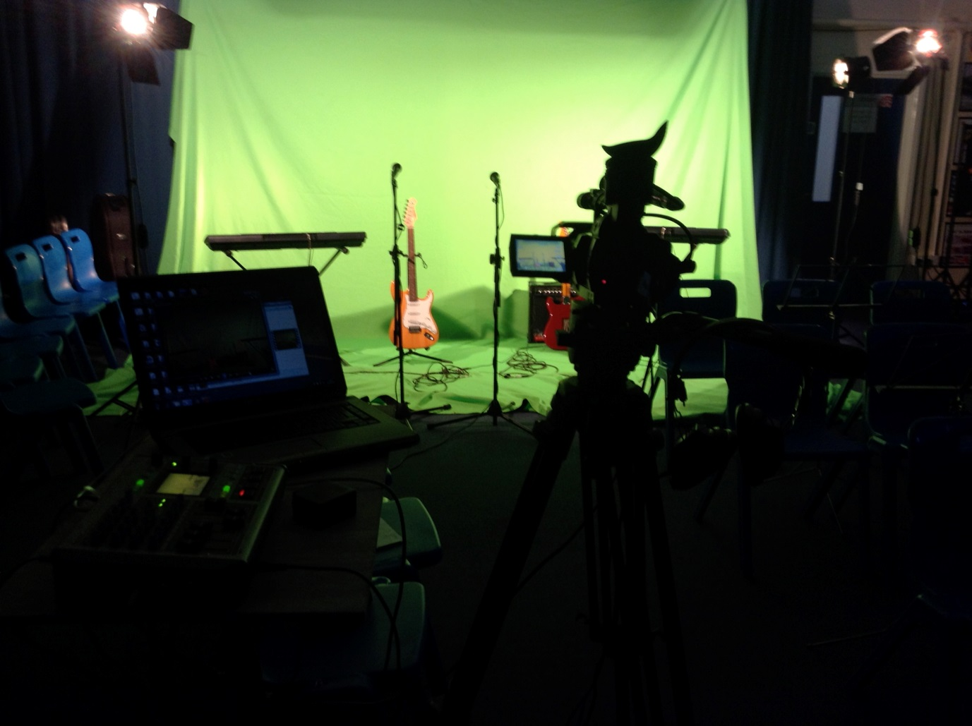

Contextual Description of the School and Faculty

The Performing Arts Faculty comprises of eleven members of staff, four of whom are peripatetic Music teachers and one who is the Performing Arts Technician. This brings a richly varied range of subject knowledge as well as teaching and learning expertise including: specialised knowledge from industry, education and teaching; ICT expertise; Performing Arts teaching and English specialists. The varied teaching backgrounds within the faculty are positive in terms of development of the delivery of the subjects and also in terms of staff development. Each is able to give support and mentoring to each other and to other colleagues across the school. Behaviour within the faculty is of a very high standard, evidenced by the nominal referrals. A major focus of the faculty is collaborative learning and pupil voice. Discussions take place in lessons and schemes of learning are evaluated at the end of topics. Students are encouraged to develop their life skills and talent in a safe and supportive environment. We incorporate and encourage independent thinking and personal learning at KS3 and KS4. The Music department is superbly equipped with two ICT classrooms and one band room, two practice rooms and a recording studio. In Year 7 and 8, all students receive one discreet hour of Dance, Music. Drama is currently only being taught in year 7, 9 and 10. Performing Arts subjects, including Media, are offered as a GCSE option where students receive two/three specialist hours per week. A key feature and strength of the faculty is its’ internationally recognised extra-curricular provision. Students have the opportunity to be involved in: Dance theatre trips, (including New York Dance Trips 2010 and 2012), Drama theatre trips, Competitions and Events to represent school on a national and international level, School Choir, Brass and Concert Band (multiple World and National Champions), Big Band (multiple National Champions), String Orchestra and Rock Bands. Students are given opportunities to perform at major venues such as The Albert Hall, Symphony Hall, The Lowry and The RNCM as well as performing in assemblies, Music Concerts, Drama Nights, Dance Shows, Fashion and Dance Shows, Open Evening, Awards Evening and Whole School Productions. The faculty is a major strength of the school in terms of teaching and learning and extra-curricular provision (Academic Excellence: Rich in Opportunity), and during the recent Ofsted inspection, all staff who were observed were graded as Outstanding.

Project Title | Real Time
Year Group | Key Stage 3 Year 8.
Key Aim | Engaging boys in the AFL process, developing critical thinking and evaluative skills.
Featured Roland Technology | Roland VR3 Audio Vision Mixer
Description | This project intended to embed new technologies and develop AFL strategies to encourage pupil progress, especially with an under achieving boys. These are issues that have been raised in the school’s recent Ofsted inspections. The project was based around the students being able to watch themselves back live and instantaneously to allow them to analyse their performances.  During the project we used the Roland VR3 Audio Vision Mixer and Green Screen technologies to engage Year 8 students. We started to make wide spread use of the Roland VR3 Audio Vision Mixer, during school productions, Drama and Dance Nights and Music Concerts. This was to greatly improve the quality of the AV used during these events. This was commented on by students, staff and other stakeholders to the school.
Scheme of Work | POP MUSIC  During this scheme of work learners develop their performance skills. Lessons are sequence to give students basic instrumental techniques on guitar, keyboards and drum kit. Learners develop an understanding of musical concepts of chords, chord sequence, ensemble, musical notation.  At the start of the sequence of lessons, learners were introduced to the final assessment, that they would be making a music video. We found that this gave the assessment a more realistic context. During the project recording and photographic evidence of the students practicing were taken. AFL strategies embedded throughout the scheme of work, learners were asked to set themselves achievable targets with the final recording in mind.  Students also work with the Performing Arts Technician during the editing process
Sequence of Learning | Lesson 1-  Learning Objective- To develop an understanding of the key terms of Chords and Chord Sequence.  Success Criteria- To perform using the 4 Chord Trick  Students watch the YouTube Clip- The 4 Chord Trick, identifying the song that used the 4 chord sequence of I, V, VI, V. Students also introduced to the idea that they will be making a music video at the end of the topic.  Student then learnt the how to play the chords and decorate them.  Lesson 2  Learning Objective- To understand how to read Tab Notation  Success Criteria- To perform either The White Stripe’s ‘Seven Nation Army’ or Deep Purple’s ‘Smoke on the Water’.  Lesson 3  Learning Objective- To develop reading of Staff Notation and keyboard skills  Success Criteria- To perform Journey’s ‘Don’t Stop Believing  Lesson 4  Learning Objective- To develop ensemble skills  Success Criteria- To form a band, which consist of guitar, keyboards, a bass part and if students want a vocal line, to perform Journey’s ‘Don’t Stop Believing’. Students are to then set themselves an agenda to perform in music video in two lessons time.  Lesson 5  Learning Objective- To continue to develop performance and ensemble skills.  Success Criteria- X FACTOR- students to watch performances from X Factor and SWOT analyse the performances. Student to use their findings to help them understand the rehearsal process. Students are to be introduced to the green screen and Roland V3.  Lesson 6  Learning Objective- To develop an understanding of the use of recording technologies in the production of music.  Success Criteria- Students to perform their versions of Don’t Stop Believing. Recording and analysing their performances using the Roland V3  Lesson 7  Learning Objective- To develop an understanding of the editing process. To assess their final product, setting musical targets for development.  Success Criteria- Students to edit their videos and to give feedback to each other.  Throughout the sequence of lessons, students were given opportunities to record and watch their performances. Student were encouraged to give critical feedback
Outcomes | The department found the use of the Roland VR3 to have positive effect on the students’ engagement and achievement. Students found the increase in final assessment gave a greater importance to the practice time during the lessons. The use of the preview screen on the Roland VR3 allowed students to assess the quality of their performance, allowing students to discuss improvements and strength. Students felt more comfortable using musical terminology when giving feedback.  After analysing the assessment data it was clear that there was a significant improvement with the students who took part in the project and also a narrowing of the gap between boys and girls achievement.  In conclusion, we found the creative use of the Roland V3 has seen significant improvements professional look of the school concerts and productions. The use of the Roland V3 in a classroom environment has seen a positive effect on the approach to assessment and the feedback that the students are giving.

